08 June 2022

****Civil Society Network for Peer Support and Localisation (ADA Türkiye) continues its activities in 15 provinces at full speed**

***Civil Society Network for Peer Support and Localisation (ADA Türkiye), established in the scope of the Community-Based Local Initiatives Project (CLIP 2), co-financed by the German Federal Ministry for Economic Cooperation and Development (BMZ) and the European Union, continues its activities at full speed. So far, the network's qualified and integrated services to refugees and vulnerable members of the host community have reached nearly 30,000 people in 15 provinces across Turkey.***

Last year, GIZ formed a Network of 22 non-governmental organisations (NGOs) that are implementation partners of the Community-Based Local Initiatives Project (CLIP 2). ADA Turkiye aims to provide needs-based social services to more than 38,000 people by August 2023 through projects run by its member NGOs in Turkey's underserved regions.

ADA Turkiye recently held its mid-term evaluation meeting in Ankara. The meeting was attended by CLIP 2 mentoring program large-scale mentors as well as representatives from the smaller-scale mentee institutions with which they are paired. The meeting, which discussed the progress made in the first phase of the mentoring program and what can be done to further expand the "multiplier effect" that will occur in the future thanks to this Network, provided an opportunity for future collaborations as well as served as a platform for peer knowledge and experience sharing.

With the support of the German government and the EU, ADA Türkiye member NGOs of different size and capacities providing services in the fields of social cohesion, non-formal education, and protection are targeting Syrian refugees, including vulnerable members of the host community as well as groups from other countries such as Afghanistan, Iraq, and Iran in their projects.

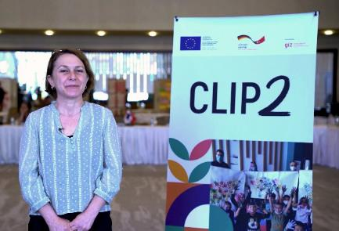CLIP 2 also assists ADA Türkiye’s corporate sustainability by allowing institutions to improve their services and increase their chances of obtaining future funding as a network. It improves coordination in the refugee response by fostering collaboration between NGO partners and the public institutions. Ebru Uzpeder from the Human Resource Development Foundation described the Network's advantages as follows: " *We have a long-term goal of living with refugees and achieving equal citizenship. With the Peer Support Network, we discussed the importance of collaboration, teamwork, and more solidarity. There isn't any other choice."*

**adaturkiye.org will be available soon!**

With the upcoming website ([www.adaturkiye.org](http://www.adaturkiye.org)), ADA Türkiye hopes to improve intra-Network coordination by increasing information sharing. The website, which is currently under construction as part of the GIZ initiative, will provide information about the Network's work as well as trainings, useful resources, and contact information of the member NGOs.

As part of the Community-Based Local Initiatives Project (CLIP 2), for which the German government and the EU have provided a total of €10,5 million in support, NGOs from ADA Türkiye had reached a total of 21,000 beneficiaries in the protection sector by March 2022. Over 1,300 people benefited from non-formal educational services, and more than 7,300 individuals took part in social cohesion activities organised by practice partners.

ADA Türkiye currently provides social services in 24 provinces, including Adana, Afyon, Ağrı, Aksaray, Amasya, Ankara, Bursa, Elazığ, Erzurum, Gaziantep, Iğdır, Istanbul, Kayseri, Kırşehir, Kilis, Konya, Kütahya, Nevşehir, Niğde, Sakarya, Sivas, Trabzon, Van and Zonguldak, with plans to expand in the future.

**Rasha's inspiring story: "To all women out there: Don’t give up!"**

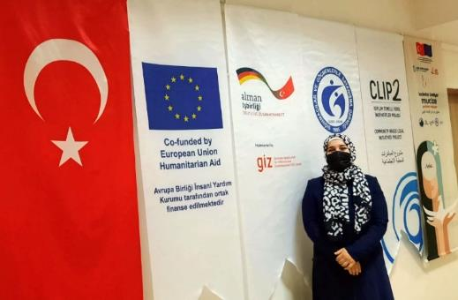Rasha, who moved to Kahramanmaraş from Aleppo with her husband and four children in 2014, despite the agonising war and migration, has written a story of resilience that will inspire all women with faith and determination. Over the years, Rasha became a role model for many of her female friends who built a new life with her efforts to work, support her family and improve herself.

“*We arrived in Turkey in winter; it was a difficult journey especially for our children. It was well worth the effort to live in peace and warmth today,”* Rasha says.

Back in Syria, Rasha had received education until the 7th grade and had no work experience. She started learning Turkish, realising the significance of breaking down the language barrier. She is currently involved in activities promoting social cohesion and capacity building at the SGDD-ASAM Ankara Community Centre supported by the Community Based Local Initiatives Project (CLIP 2).

"*SGDD-ASAM supports and empowers women, no matter how vulnerable they may feel,*" Rasha says. Despite the challenges of the COVID-19 pandemic, she praises the assistance she receives from the Ankara Community Centre staff in getting her children registered in school. When she describes the overall improvement in her family's resilience, she adds, "*My neighbours introduced SGDD-ASAM as an institution that supports women.*"

Although she encountered the language barrier and did not have a profession in those days, her ability to mesh and thus earn income sown the first seeds of Rasha's success in the Women's Cooperative today. Rasha has been working as one of the most active members of the **BERI Women's Cooperative** for three years and claims that hat after she started receiving knitting and sewing orders her cooperative friends trust her in helping them improve their professional skills; therefore, they have picked up on her business ideas.

"*I hope our project will be our strength, our dream and our triumph,*" Rasha says. “*No matter how much I explain, words are insufficient. We exist as BERI, not as Turks or Syrians.*"

Rasha is much more cohesive and more resilient now than it was eight years ago. Rasha sends a message to those who want to be entrepreneurs like herself, explaining that they face many challenges when they first start working in the cooperative: "*To all the women out there: Let’s make our dreams come true. Let’s follow our dreams and make them true. “Allow yourself to do whatever you want. Infuse your love and strength into everything. As a result, you will achieve great success in any field.*"

*The project “Improving Community-based Social Services for Refugees and Vulnerable Residents of Host Communities in Turkey (CLIP 2)” is co-funded by the German Federal Ministry for Economic Cooperation and Development (BMZ) and the European Union, through its Humanitarian Aid Operations department (ECHO) and implemented by Deutsche Gesellschaft für Internationale Zusammenarbeit (GIZ) GmbH.*

**For more information:**

Didem Ayberkin-Yüksel, Communication Specialist

[*didem.ayberkin@giz.de*](mailto:didem.ayberkin@giz.de) */ +90 549 827 56 58*

[CLIP 2 Facebook](https://www.facebook.com/CLIPTurkey)

[CLIP 2 Twitter](https://twitter.com/CLIPTurkey)